EXP NO: 3

DATE: 09/03/24

DIGITAL SIGNATURE ALGORITHM

AIM:

To implement Digital Signature Algorithm (DSA) using C.

ALGORITHM:

1. Get the prime number p and its divisor q from the user.
2. Get the value of h from the user.
3. Compute the value of g.
4. Get the private key xa from the user.
5. Compute the user's public key y.
6. Get the per-message secret key k and hash value of message M.
7. Compute the value of z using g, k & p
8. Compute z % q to get the value of r
9. Compute the multiplicative inverse. 10.Compute the value of s.
10. Print the signature (r, s).

PROGRAM:

#include <stdio.h> #include <math.h>

int power(int,unsigned int,int);

int multiplicativeInverse(int,int,int); int main()

{

int p,q,h,g,r,s,t,x,y,z,k,inv,hash;

printf("\nEnter prime number p and enter q prime divisor of (p-1): ");

scanf("%d %d",&p,&q);

printf("\nEnter h such that it greater than 1 and less than (p-1): ");

scanf("%d",&h);

//Compute g t = (p-1)/q;

g = power(h,t,p);

printf("\nEnter user's private key such that it is greater than 0 and less than q : "); scanf("%d",&x);

//Computer user's public key

y = power(g,x,p);

printf("\nEnter user's per-message secret key k such that it is greater than 0 and less than q : "); scanf("%d",&k);

printf("\nEnter the hash(M) value : "); scanf("%d",&hash);

//Signing. Compute r and s pair z = power(g,k,p);

r = z % q;

inv = multiplicativeInverse(k,q,p); s = inv \* (hash + x \* r) % q;

//Display

printf("\n\*\*\*\*\*\*\*\*\*Computed Values\*\*\*\*\*\*\*\*\*"); printf("\ng = %d",g);

printf("\ny = %d",y);

printf("\nGenerated Signature Sender = (%d, %d) \n",r,s);

}

int power(int x, unsigned int y, int p)

{

int res = 1; // Initialize result

x = x % p; // Update x if it is more than or equal to p while (y > 0)

{

// If y is odd, multiply x with result if (y & 1)

res = (res \* x) % p;

// y must be even now y = y >> 1; // y = y/2 x = (x \* x) % p;

}

return res;

}

int multiplicativeInverse(int a, int b, int n)

{

int sum,x,y; for(y=0;y<n;y++)

{

for(x=0;x<n;x++)

{

sum = a \* x + b \* (-y); if(sum == 1)

return x;

}

}

}

OUTPUT:

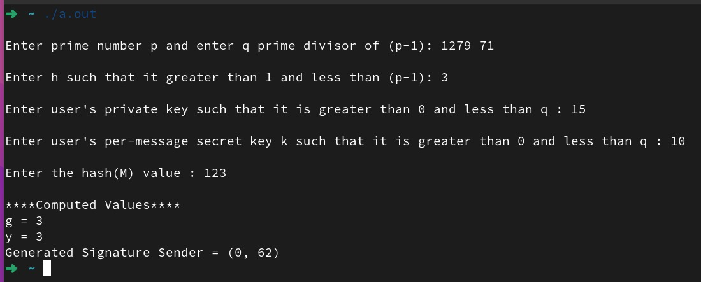

RESULT:

Thus, a C program is implemented to demonstrate Digital Signature Algorithm.